* **SUBSET SUM PROBLEM using DP:**

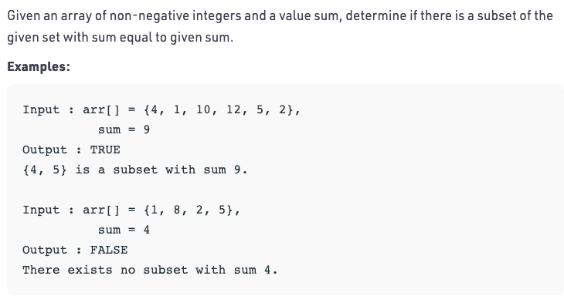

**-> Soln1: O(n*sum) time and space.**

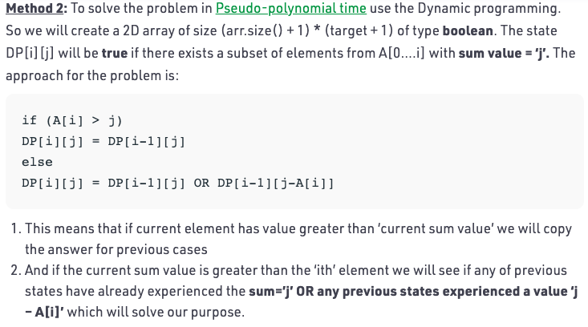

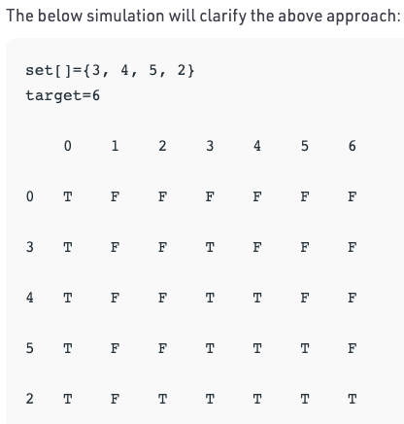

**Code :** [**O(n*sum) time and space**](https://ide.geeksforgeeks.org/iCNVuQDCZs)

**Soln2 : O(sum) space**

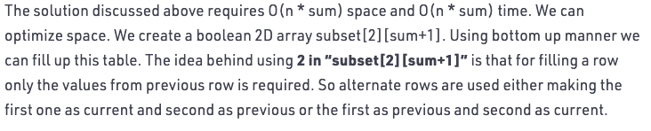

**Code :** [**O(n*sum) time and O(sum) space**](https://ide.geeksforgeeks.org/j5dyz1Xx9s)

**=> Print all Subsets with given Sum:**

Code : <https://ide.geeksforgeeks.org/4Vz9wJYLUA>

**Time = 2^n where n=no of elements in array**

As all 2^n subsets of a set might sum up to given Sum